DOCUMENTAZIONE FOTOGRAFICA

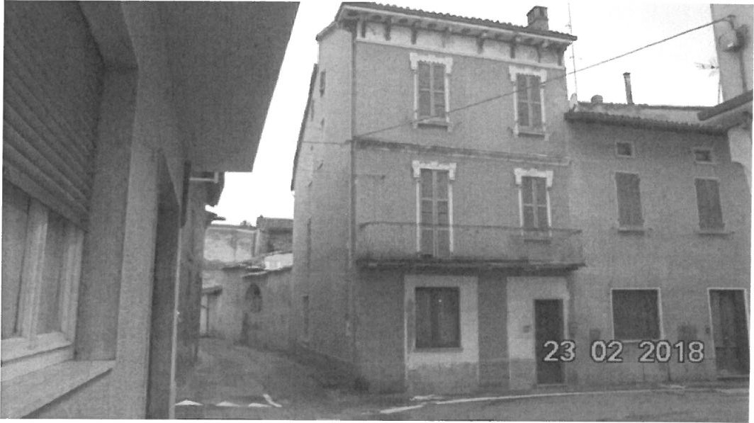

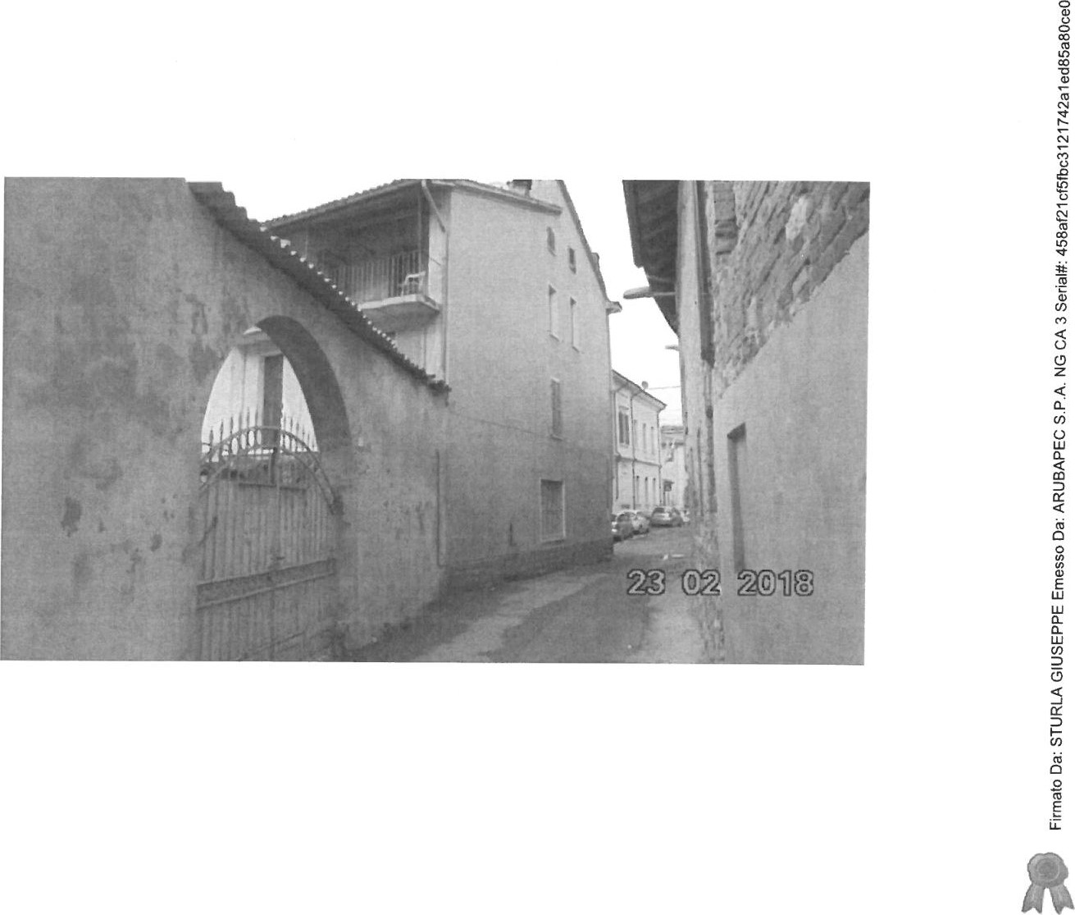

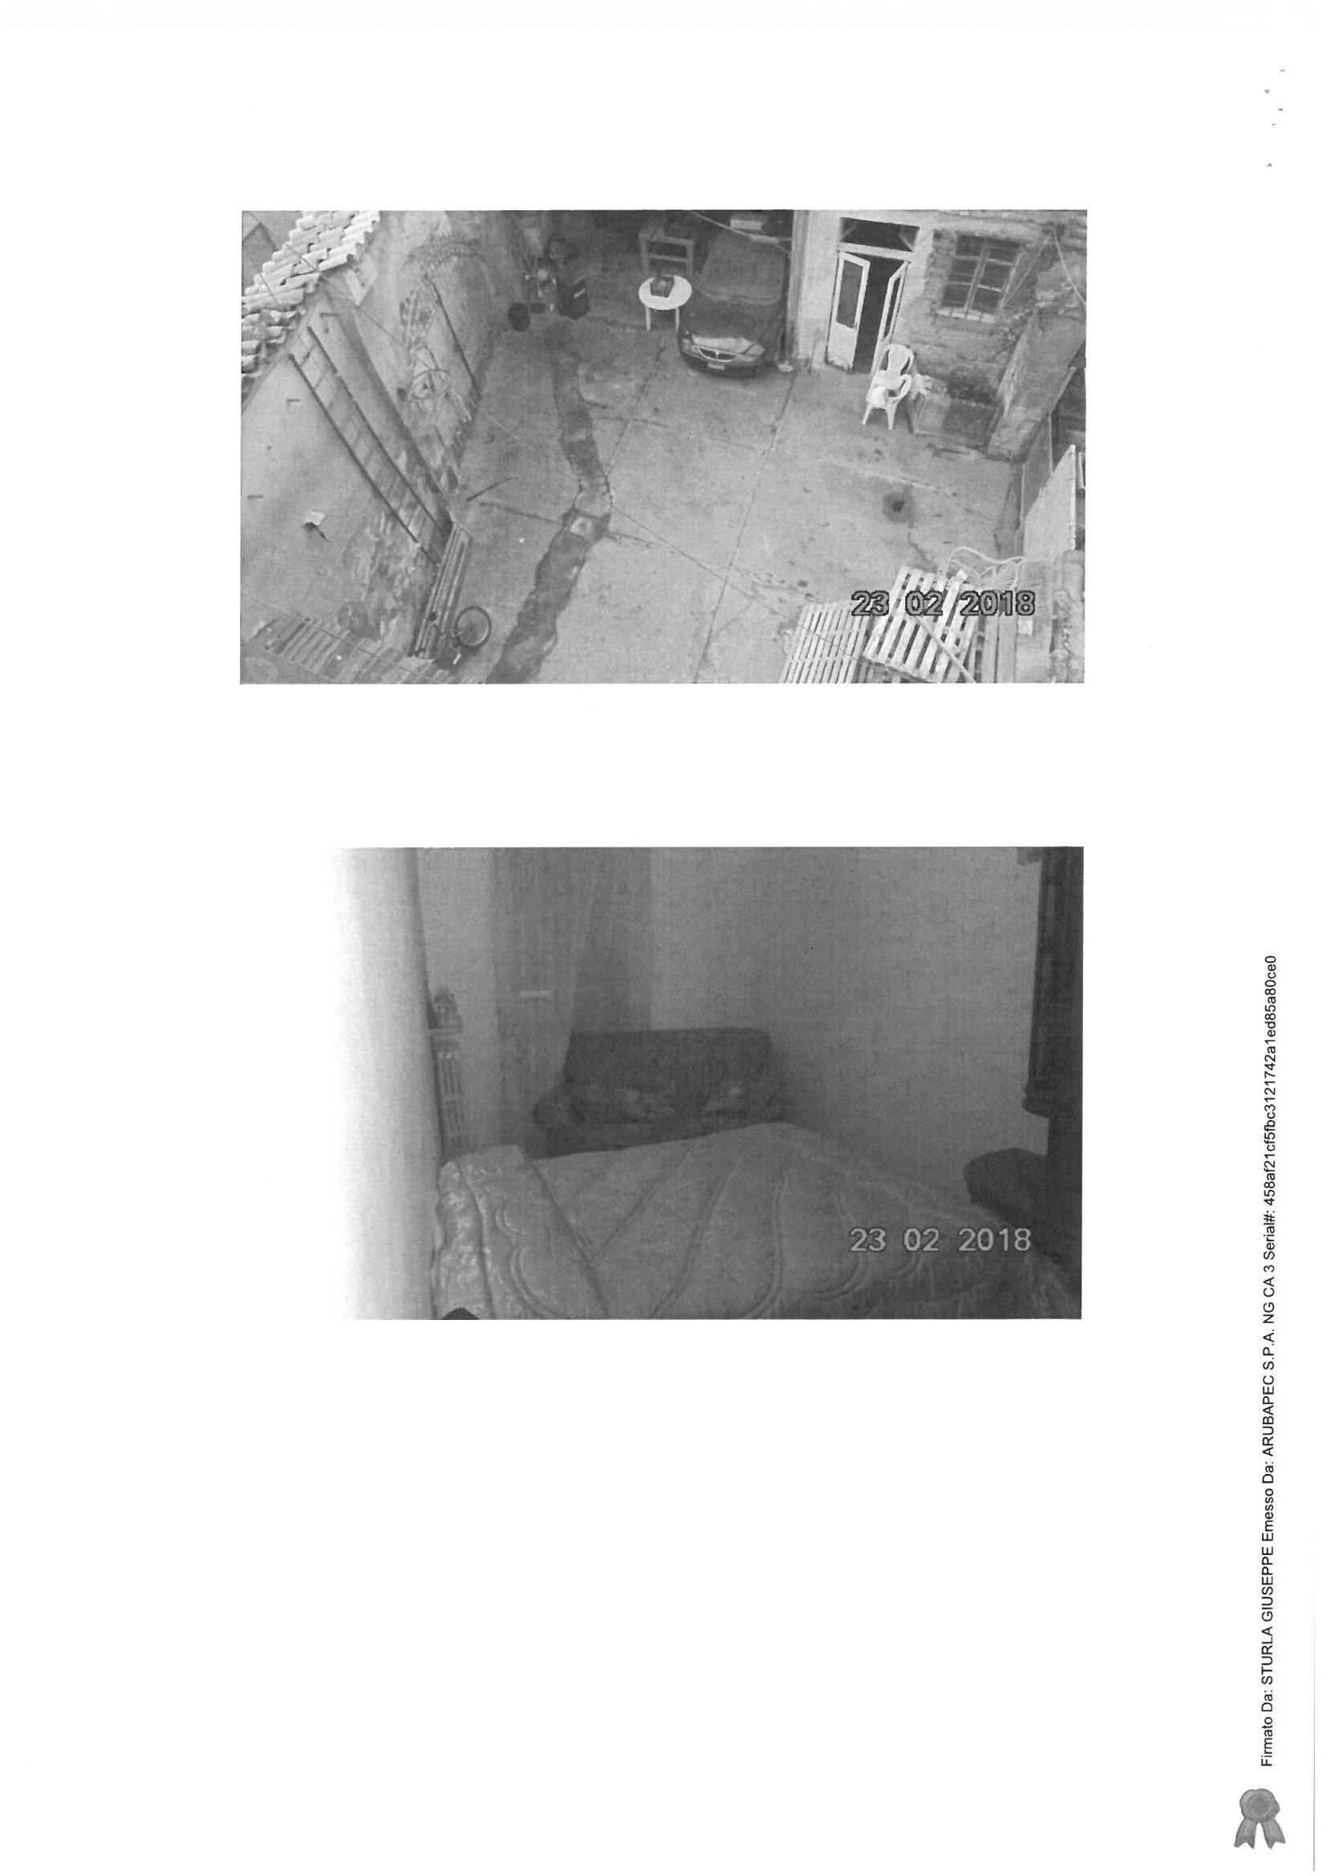

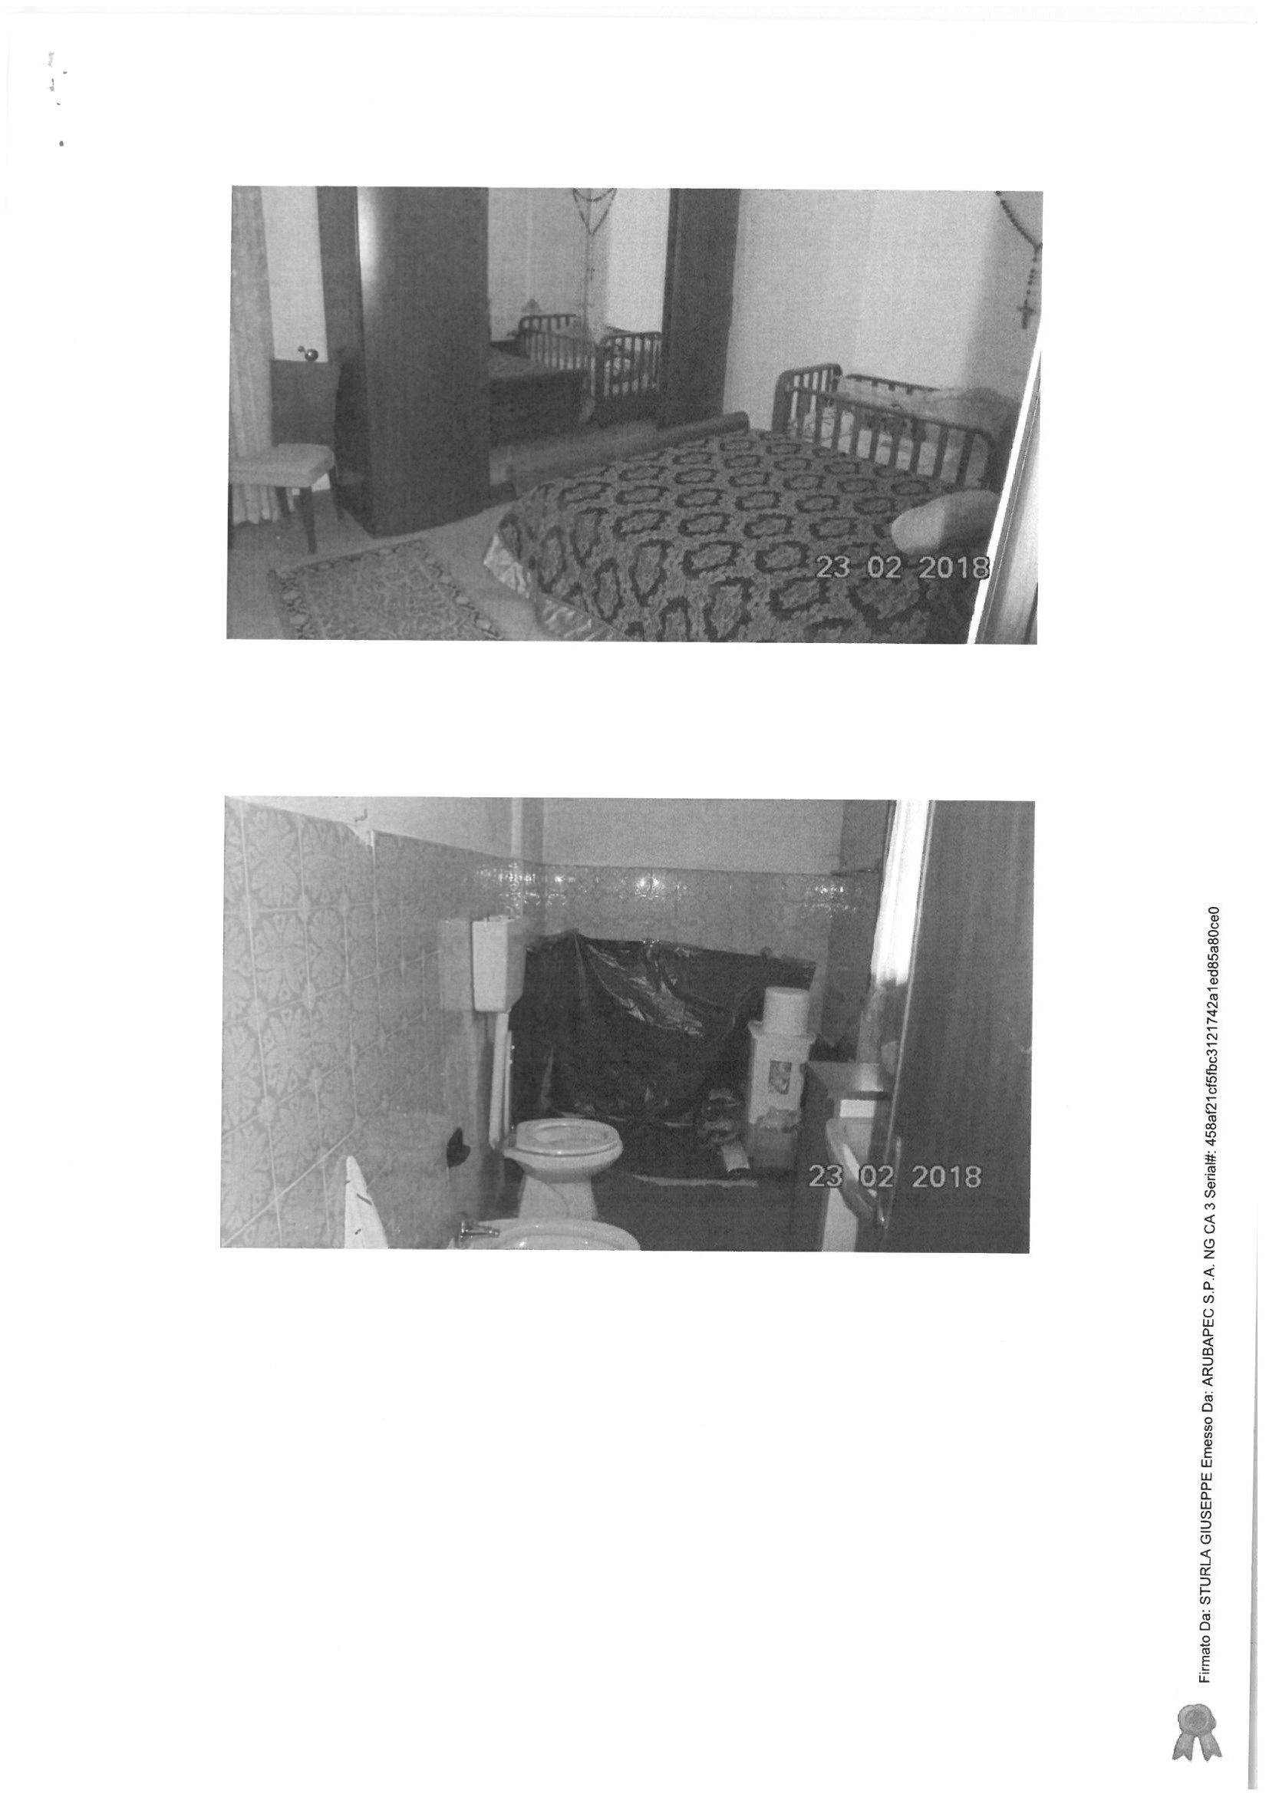

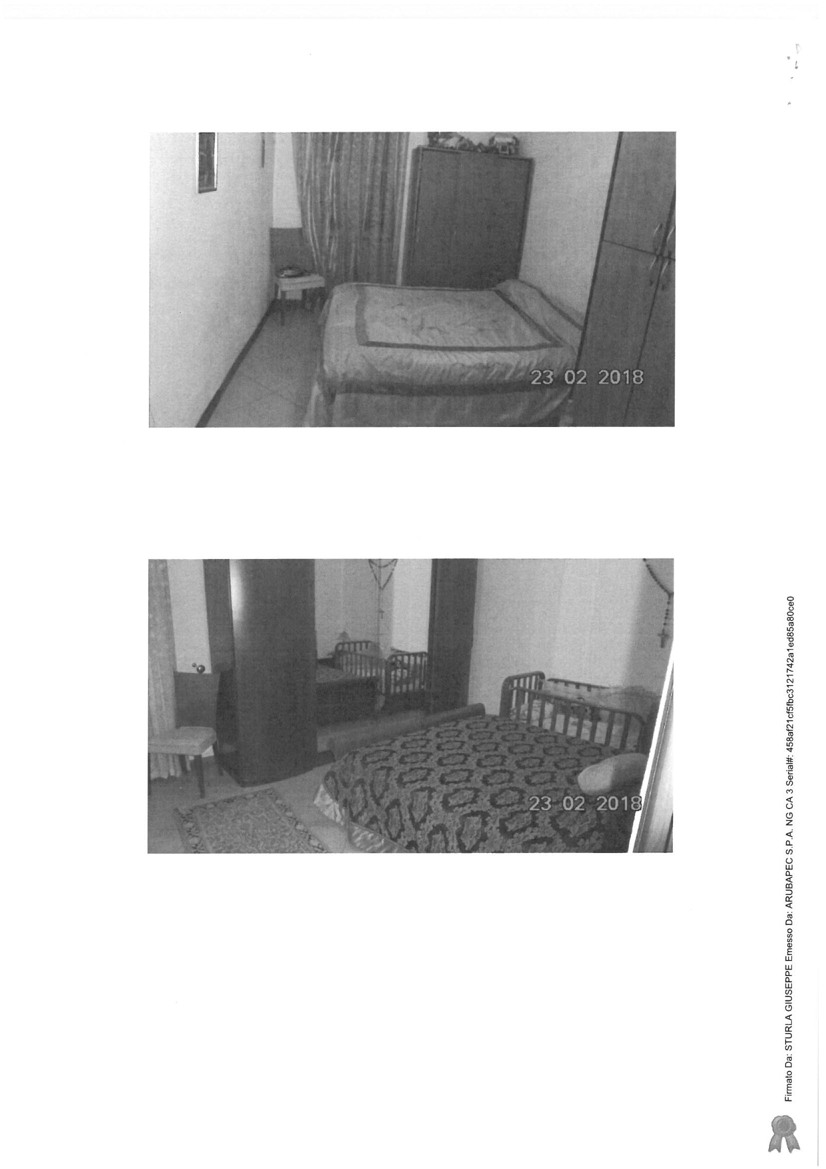

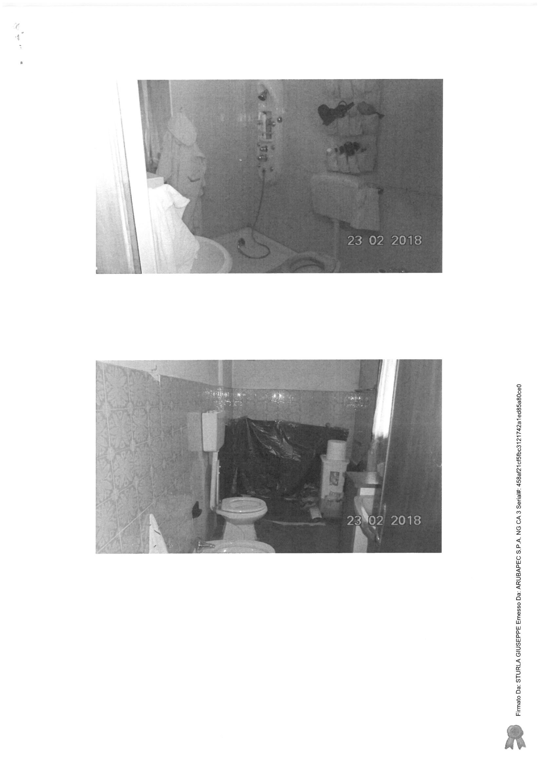

|  |  |  |  |  |  |
| --- | --- | --- | --- | --- | --- |
|  |  |  |  | 201 | 8 |
|  |

|  |  |  |  |  |  |  |
| --- | --- | --- | --- | --- | --- | --- |
|  |  |  |  | 02 | 901 |  |
| 8 |
|  |

5